Super Store Sales And Trend Analysis
1.Project Overview
This project analyses Super Store sales and trend performance across products, regions, category, and sales channels to identify key drivers, seasonal trends, and actionable growth opportunities.
2.Data Summary
- The dataset contains 9,800 observations across 18 parameters.
- Key Features
  - Order details (Order ID, Order Date, Ship Date, Ship Mode)
  - Customer Details (Customer ID, Customer Name, Segment)
  - Geographical Details (Country, Region, State, City)
  - Product Details (Product ID, Product Name, Category, Sub-Category)
  - Key Metrics (Sales)

3.EDA- (Exploratory Data Analysis)
- Nulls & Duplicates
  - Verify the null values and duplicated data using SQL query
    - The data does not contain any null values and there are no presence of duplicate entries.
4. Data Analyses Using SQL
1.Total Sales: $22,59,845
2.Total Orders: 4,922
3.Total Customers: 793

1.Average Shipping Days
Ship_mode | Avg_ship_days
Standard Class | 5
Second Class | 3
First Class | 2
Same Day | 0

2.Total Sales by Ship Mode
Ship_mode | Total_Sales | overall_Sales | Contribution
Standard Class | 1340122 | 2259845 | 59.30%
Second Class | 448981 | 2259845 | 19.87%
First Class | 345523 | 2259845 | 15.29%
Same Day | 125219 | 2259845 | 5.54%
3.Total Orders by Ship_Mode
Ship_mode | Total_Orders | overall_orders | Contribution
Standard Class | 2945 | 4922 | 59.83%
Second Class | 944 | 4922 | 19.18%
First Class | 772 | 4922 | 15.68%
Same Day | 261 | 4922 | 5.30%

4.Total Sales by Segment
Segment | Total_Sales | overall_Sales | Contribution
Consumer | 1147672 | 2259846 | 50.79%
Corporate | 687950 | 2259846 | 30.44%
Home Office | 424224 | 2259846 | 18.77%

5. Total Orders by Segment
Segment | Total_Orders | overall_orders | Contribution
Consumer | 2537 | 4922 | 51.54%
Corporate | 1491 | 4922 | 30.29%
Home Office | 894 | 4922 | 18.16%

6.Total Sales by Region
Region | Total_Sales | overall_Sales | Contribution
West | 710117 | 2259845 | 31.42%
East | 668644 | 2259845 | 29.59%
Central | 492647 | 2259845 | 21.80%
South | 388437 | 2259845 | 17.19%

7.Total Orders by Region
Region | Total_Orders | overall_orders | Contribution
West | 1587 | 4922 | 32.24%
East | 1369 | 4922 | 27.81%
Central | 1156 | 4922 | 23.49%
South | 810 | 4922 | 16.46%

8.Total Sales by State
Region | State | Total_Sales | overall_Sales | Contribution
Central | Texas | 168573 | 2259845 | 7.46%
Central | Illinois | 79237 | 2259845 | 3.51%
Central | Michigan | 76136 | 2259845 | 3.37%
Central | Indiana | 48718 | 2259845 | 2.16%
Central | Wisconsin | 31173 | 2259845 | 1.38%
Central | Minnesota | 29863 | 2259845 | 1.32%
Central | Missouri | 22205 | 2259845 | 0.98%
Central | Oklahoma | 19683 | 2259845 | 0.87%
Central | Nebraska | 7465 | 2259845 | 0.33%
Central | Iowa | 4444 | 2259845 | 0.20%
Central | Kansas | 2914 | 2259845 | 0.13%
Central | South Dakota | 1316 | 2259845 | 0.06%
Central | North Dakota | 920 | 2259845 | 0.04%
East | New York | 306312 | 2259845 | 13.55%
East | Pennsylvania | 116277 | 2259845 | 5.15%
East | Ohio | 74849 | 2259845 | 3.31%
East | New Jersey | 34611 | 2259845 | 1.53%
East | Massachusetts | 28634 | 2259845 | 1.27%
East | Delaware | 27323 | 2259845 | 1.21%
East | Maryland | 23161 | 2259845 | 1.02%
East | Rhode Island | 22525 | 2259845 | 1%
East | Connecticut | 13384 | 2259845 | 0.59%
East | Vermont | 8929 | 2259845 | 0.40%
East | New Hampshire | 7293 | 2259845 | 0.32%
East | District of Columbia | 2865 | 2259845 | 0.13%
East | Maine | 1271 | 2259845 | 0.06%
East | West Virginia | 1210 | 2259845 | 0.05%
South | Florida | 88437 | 2259845 | 3.91%
South | Virginia | 70350 | 2259845 | 3.11%
South | North Carolina | 54874 | 2259845 | 2.43%
South | Georgia | 48219 | 2259845 | 2.13%
South | Kentucky | 36368 | 2259845 | 1.61%
South | Tennessee | 30662 | 2259845 | 1.36%
South | Alabama | 19511 | 2259845 | 0.86%
South | Arkansas | 11678 | 2259845 | 0.52%
South | Mississippi | 10726 | 2259845 | 0.47%
South | Louisiana | 9131 | 2259845 | 0.40%
South | South Carolina | 8482 | 2259845 | 0.38%
West | California | 446306 | 2259845 | 19.75%
West | Washington | 135207 | 2259845 | 5.98%
West | Arizona | 35273 | 2259845 | 1.56%
West | Colorado | 31739 | 2259845 | 1.40%
West | Oregon | 17284 | 2259845 | 0.76%
West | Nevada | 16729 | 2259845 | 0.74%
West | Utah | 11220 | 2259845 | 0.50%
West | Montana | 5589 | 2259845 | 0.25%
West | New Mexico | 4784 | 2259845 | 0.21%
West | Idaho | 4382 | 2259845 | 0.19%
West | Wyoming | 1603 | 2259845 | 0.07%

9.Total Orders by State
Region | State | Total_Orders | overall_orders | Contribution
Central | Texas | 480 | 4922 | 9.75%
Central | Illinois | 270 | 4922 | 5.49%
Central | Michigan | 116 | 4922 | 2.36%
Central | Indiana | 70 | 4922 | 1.42%
Central | Wisconsin | 52 | 4922 | 1.06%
Central | Minnesota | 44 | 4922 | 0.89%
Central | Oklahoma | 34 | 4922 | 0.69%
Central | Missouri | 30 | 4922 | 0.61%
Central | Nebraska | 23 | 4922 | 0.47%
Central | Iowa | 16 | 4922 | 0.33%
Central | Kansas | 14 | 4922 | 0.28%
Central | South Dakota | 5 | 4922 | 0.10%
Central | North Dakota | 2 | 4922 | 0.04%
East | New York | 547 | 4922 | 11.11%
East | Pennsylvania | 285 | 4922 | 5.79%
East | Ohio | 227 | 4922 | 4.61%
East | Massachusetts | 62 | 4922 | 1.26%
East | New Jersey | 58 | 4922 | 1.18%
East | Maryland | 46 | 4922 | 0.93%
East | Connecticut | 45 | 4922 | 0.91%
East | Delaware | 43 | 4922 | 0.87%
East | Rhode Island | 24 | 4922 | 0.49%
East | New Hampshire | 17 | 4922 | 0.35%
East | Vermont | 6 | 4922 | 0.12%
East | District of Columbia | 4 | 4922 | 0.08%
East | Maine | 3 | 4922 | 0.06%
East | West Virginia | 2 | 4922 | 0.04%
South | Florida | 197 | 4922 | 4%
South | North Carolina | 134 | 4922 | 2.72%
South | Virginia | 115 | 4922 | 2.34%
South | Tennessee | 91 | 4922 | 1.85%
South | Georgia | 87 | 4922 | 1.77%
South | Kentucky | 59 | 4922 | 1.20%
South | Alabama | 34 | 4922 | 0.69%
South | Arkansas | 27 | 4922 | 0.55%
South | Mississippi | 26 | 4922 | 0.53%
South | Louisiana | 20 | 4922 | 0.41%
South | South Carolina | 20 | 4922 | 0.41%
West | California | 1002 | 4922 | 20.36%
West | Washington | 254 | 4922 | 5.16%
West | Arizona | 107 | 4922 | 2.17%
West | Colorado | 78 | 4922 | 1.58%
West | Oregon | 55 | 4922 | 1.12%
West | Utah | 26 | 4922 | 0.53%
West | Nevada | 23 | 4922 | 0.47%
West | New Mexico | 22 | 4922 | 0.45%
West | Idaho | 11 | 4922 | 0.22%
West | Montana | 8 | 4922 | 0.16%
West | Wyoming | 1 | 4922 | 0.02%

10.Total Sales by Category
Category | Total_Sales | overall_Sales | Contribution
Technology | 827062 | 2259846 | 36.60%
Furniture | 728091 | 2259846 | 32.22%
Office Supplies | 704693 | 2259846 | 31.18%

11.Total Orders by Category
Category | Total_Orders | overall_orders | Contribution
Office Supplies | 3676 | 6922 | 53.11%
Furniture | 1727 | 6922 | 24.95%
Technology | 1519 | 6922 | 21.94%
---
12.Total Sales by Sub-Category
Category | Sub_Category | Total_Sales | overall_Sales | Contribution
Furniture | Chairs | 322541 | 2259845 | 14.27%
Furniture | Tables | 202811 | 2259845 | 8.97%
Furniture | Bookcases | 113813 | 2259845 | 5.04%
Furniture | Furnishings | 88926 | 2259845 | 3.94%
Office Supplies | Storage | 218799 | 2259845 | 9.68%
Office Supplies | Binders | 199939 | 2259845 | 8.85%
Office Supplies | Appliances | 104618 | 2259845 | 4.63%
Office Supplies | Paper | 76734 | 2259845 | 3.40%
Office Supplies | Supplies | 46420 | 2259845 | 2.05%
Office Supplies | Art | 26705 | 2259845 | 1.18%
Office Supplies | Envelopes | 16128 | 2259845 | 0.71%
Office Supplies | Labels | 12348 | 2259845 | 0.55%
Office Supplies | Fasteners | 3002 | 2259845 | 0.13%
Technology | Phones | 327782 | 2259845 | 14.50%
Technology | Machines | 189239 | 2259845 | 8.37%
Technology | Accessories | 163792 | 2259845 | 7.25%
Technology | Copiers | 146248 | 2259845 | 6.47%

13.Total Orders by Sub-Category
Category | Sub_Category | Total_Orders | overall_orders | Contribution
Furniture | Furnishings | 855 | 8986 | 9.51%
Furniture | Chairs | 566 | 8986 | 6.30%
Furniture | Tables | 302 | 8986 | 3.36%
Furniture | Bookcases | 222 | 8986 | 2.47%
Office Supplies | Binders | 1291 | 8986 | 14.37%
Office Supplies | Paper | 1163 | 8986 | 12.94%
Office Supplies | Storage | 764 | 8986 | 8.50%
Office Supplies | Art | 720 | 8986 | 8.01%
Office Supplies | Appliances | 444 | 8986 | 4.94%
Office Supplies | Labels | 340 | 8986 | 3.78%
Office Supplies | Envelopes | 243 | 8986 | 2.70%
Office Supplies | Fasteners | 212 | 8986 | 2.36%
Office Supplies | Supplies | 181 | 8986 | 2.01%
Technology | Phones | 803 | 8986 | 8.94%
Technology | Accessories | 702 | 8986 | 7.81%
Technology | Machines | 112 | 8986 | 1.25%
Technology | Copiers | 66 | 8986 | 0.73%

14. Top 5 Selling Sub-Categories by Sales
Category | Sub_Category | Total_Sales | overall_Sales | Contribution
Technology | Phones | 327782 | 2259845 | 14.50%
Furniture | Chairs | 322541 | 2259845 | 14.27%
Office Supplies | Storage | 218799 | 2259845 | 9.68%
Furniture | Tables | 202811 | 2259845 | 8.97%
Office Supplies | Binders | 199939 | 2259845 | 8.85%

15. Bottom 5 Selling Sub-Categories by Sales
Category | Sub_Category | Total_Sales | overall_Sales | Contribution
Office Supplies | Fasteners | 3002 | 2259845 | 0.13%
Office Supplies | Labels | 12348 | 2259845 | 0.55%
Office Supplies | Envelopes | 16128 | 2259845 | 0.71%
Office Supplies | Art | 26705 | 2259845 | 1.18%
Office Supplies | Supplies | 46420 | 2259845 | 2.05%

16. Top 5 Selling Sub-Categories by Orders
Category | Sub_Category | Total_Orders | overall_orders | Contribution
Office Supplies | Binders | 1291 | 8986 | 14.37%
Office Supplies | Paper | 1163 | 8986 | 12.94%
Furniture | Furnishings | 855 | 8986 | 9.51%
Technology | Phones | 803 | 8986 | 8.94%
Office Supplies | Storage | 764 | 8986 | 8.50%

17.Bottom 5 Selling Sub-Categories by Orders
Category | Sub_Category | Total_Orders | overall_orders | Contribution
Technology | Copiers | 66 | 8986 | 0.73%
Technology | Machines | 112 | 8986 | 1.25%
Office Supplies | Supplies | 181 | 8986 | 2.01%
Office Supplies | Fasteners | 212 | 8986 | 2.36%
Furniture | Bookcases | 222 | 8986 | 2.47%

18.Top 10 Selling Products by Sales
Category | Sub_Category | Product_Name | Total_Sales
Technology | Copiers | Canon imageCLASS 2200 Advanced Copier | 61600
Office Supplies | Binders | Fellowes PB500 Electric Punch Plastic Comb Binding Machine with Manual Bind | 27453
Technology | Machines | Cisco TelePresence System EX90 Videoconferencing Unit | 22638
Furniture | Chairs | HON 5400 Series Task Chairs for Big and Tall | 21871
Office Supplies | Binders | GBC DocuBind TL300 Electric Binding System | 19823
Office Supplies | Binders | GBC Ibimaster 500 Manual ProClick Binding System | 19024
Technology | Copiers | Hewlett Packard LaserJet 3310 Copier | 18840
Technology | Machines | HP Designjet T520 Inkjet Large Format Printer - 24" Color | 18375
Office Supplies | Binders | GBC DocuBind P400 Electric Binding System | 17965
Office Supplies | Supplies | High Speed Automatic Electric Letter Opener | 17030

19.Least 10 Selling Products by Sales
Category | Sub_Category | Product_Name | Total_Sales
Office Supplies | Appliances | Eureka Disposable Bags for Sanitaire Vibra Groomer I Upright Vac | 2
Office Supplies | Labels | Avery 5 | 6
Office Supplies | Paper | Xerox 20 | 6
Office Supplies | Envelopes | Grip Seal Envelopes | 7
Office Supplies | Art | 4009 Highlighters | 8
Office Supplies | Art | Avery Hi-Liter Comfort Grip Fluorescent Highlighter, Yellow Ink | 8
Office Supplies | Art | Avery Hi-Liter Pen Style Six-Color Fluorescent Set | 8
Office Supplies | Art | Newell 308 | 8
Office Supplies | Binders | Acco Economy Flexible Poly Round Ring Binder | 8
Office Supplies | Fasteners | Stockwell Gold Paper Clips | 8

20.Top 10 Selling Products by Orders
Category | Sub_Category | Product_Name | Total_Orders
Office Supplies | Envelopes | Staple envelope | 47
Office Supplies | Fasteners | Staples | 46
Office Supplies | Paper | Easy-staple paper | 44
Office Supplies | Binders | Avery Non-Stick Binders | 20
Office Supplies | Art | Staples in misc. colors | 18
Office Supplies | Supplies | Staple remover | 18
Furniture | Tables | KI Adjustable-Height Table | 17
Office Supplies | Binders | Storex Dura Pro Binders | 17
Furniture | Furnishings | Staple-based wall hangings | 16
Furniture | Chairs | Situations Contoured Folding Chairs, 4/Set | 15

21.Least 10 Selling Products by Orders
Category | Sub_Category | Product_Name | Total_Orders
Furniture | Bookcases | Bush Saratoga Collection 5-Shelf Bookcase, Hanover Cherry, *Special Order | 1
Furniture | Bookcases | Bush Birmingham Collection Bookcase, Dark Cherry | 1
Furniture | Bookcases | Bush Westfield Collection Bookcases, Dark Cherry Finish, Fully Assembled | 1
Furniture | Chairs | Global Enterprise Series Seating Low-Back Swivel/Tilt Chairs | 1
Furniture | Furnishings | Eldon Econocleat Chair Mats for Low Pile Carpets | 1
Furniture | Furnishings | Linden 12" Wall Clock With Oak Frame | 1
Furniture | Furnishings | Ultra Commercial Grade Dual Valve Door Closer | 1
Furniture | Tables | Barricks Non-Folding Utility Table with Steel Legs, Laminate Tops | 1
Office Supplies | Appliances | Belkin 7 Outlet SurgeMaster Surge Protector with Phone Protection | 1
Office Supplies | Appliances | Belkin 8 Outlet SurgeMaster II Gold Surge Protector with Phone Protection | 1
Trend Analysis
22.Year Wise sales Analysis
Years | Total_Sales
2015 | 479575
2016 | 459346
2017 | 599519
2018 | 721405
-Yearly Contribution
Years | Total_Sales | Overall_sales | Contribution
2016 | 459346 | 2259845 | 20.33%
2015 | 479575 | 2259845 | 21.22%
2017 | 599519 | 2259845 | 26.53%
2018 | 721405 | 2259845 | 31.92%

-YOY Performance analysis
Years | Total_Sales | py_sales | Sales_Diff | Sales_Status | YOY_perf
2015 | 479575 | NULL | NULL | No Previous Value | 0
2016 | 459346 | 479575 | -20229 | Decreasing | -4.22%
2017 | 599519 | 459346 | 140173 | Increasing | 30.52%
2018 | 721405 | 599519 | 121886 | Increasing | 20.33%

23.Year wise Order Analysis
Years | Total_Orders
2015 | 947
2016 | 1019
2017 | 1295
2018 | 1661
Year wise contribution Analysis
Years | Total_Orders | Overall_Orders | Contribution
2018 | 1661 | 4922 | 33.75%
2017 | 1295 | 4922 | 26.31%
2016 | 1019 | 4922 | 20.70%
2015 | 947 | 4922 | 19.24%
YOY Performance
Years | Total_Orders | py_orders | Diff | Order_Status | YOY_perf
2015 | 947 | NULL | NULL | No Previous Value | 0%
2016 | 1019 | 947 | 72 | Increasing | 7.60%
2017 | 1295 | 1019 | 276 | Increasing | 27.09%
2018 | 1661 | 1295 | 366 | Increasing | 28.26%

24.Quarterly Analysis
quarter_of_the_year | Total_Sales
Q1 | 351191
Q2 | 435634
Q3 | 602816
Q4 | 870205
--Quarterly Contribution
quarter_of_the_year | Total_Sales | Overall_sales | Contribution
Q4 | 870205 | 2259846 | 38.51%
Q3 | 602816 | 2259846 | 26.68%
Q2 | 435634 | 2259846 | 19.28%
Q1 | 351191 | 2259846 | 15.54%
----Performance
quarter_of_the_year | Total_Sales | pq_sales | Diff | Sales_Status | YOY_perf
Q1 | 351191 | NULL | NULL | No Previous Value | 0%
Q2 | 435634 | 351191 | 84443 | Increasing | 24.04%
Q3 | 602816 | 435634 | 167182 | Increasing | 38.38%
Q4 | 870205 | 602816 | 267389 | Increasing | 44.36%

25.Quarterly Analysis by Order
quarter_of_the_year | Total_Orders
Q1 | 681
Q2 | 1054
Q3 | 1340
Q4 | 1847
--Contribution
quarter_of_the_year | Total_Orders | Overall_orders | Contribution
Q4 | 1847 | 4922 | 37.53%
Q3 | 1340 | 4922 | 27.22%
Q2 | 1054 | 4922 | 21.41%
Q1 | 681 | 4922 | 13.84%
--Performance
quarter_of_the_year | Total_Orders | pq_orders | Diff | order_status | quart_perf
Q1 | 681 | NULL | NULL | No Previous Value | 0
Q2 | 1054 | 681 | 373 | Increasing | 54.77
Q3 | 1340 | 1054 | 286 | Increasing | 27.13
Q4 | 1847 | 1340 | 507 | Increasing | 37.84

26.Monthly Sales Analysis
Months | Total_Sales
Jan | 94292
Feb | 59371
Mar | 197528
Apr | 135710
May | 154087
Jun | 145838
Jul | 145446
Aug | 157316
Sep | 300054
Oct | 199496
Nov | 349617
Dec | 321091

-Monthly Contribution
Months | Total_Sales | Overall_sales | Contribution
Nov | 349617 | 2259846 | 15.47%
Dec | 321091 | 2259846 | 14.21%
Sep | 300054 | 2259846 | 13.28%
Oct | 199496 | 2259846 | 8.83%
Mar | 197528 | 2259846 | 8.74%
Aug | 157316 | 2259846 | 6.96%
May | 154087 | 2259846 | 6.82%
Jun | 145838 | 2259846 | 6.45%
Jul | 145446 | 2259846 | 6.44%
Apr | 135710 | 2259846 | 6.01%
Jan | 94292 | 2259846 | 4.17%
Feb | 59371 | 2259846 | 2.63%
--Monthly Performance
Months | Total_Sales | pm_sales | sales_diff | Sales_Status | YOY_perf
Jan | 94292 | NULL | NULL | No Previous Value | 0
Feb | 59371 | 94292 | -34921 | Decreasing | -37.03
Mar | 197528 | 59371 | 138157 | Increasing | 232.7
Apr | 135710 | 197528 | -61818 | Decreasing | -31.3
May | 154087 | 135710 | 18377 | Increasing | 13.54
Jun | 145838 | 154087 | -8249 | Decreasing | -5.35
Jul | 145446 | 145838 | -392 | Decreasing | -0.27
Aug | 157316 | 145446 | 11870 | Increasing | 8.16
Sep | 300054 | 157316 | 142738 | Increasing | 90.73
Oct | 199496 | 300054 | -100558 | Decreasing | -33.51
Nov | 349617 | 199496 | 150121 | Increasing | 75.25
Dec | 321091 | 349617 | -28526 | Decreasing | -8.16
27.Monthly Order Analysis
Months | Total_Orders
Jan | 174
Feb | 161
Mar | 346
Apr | 337
May | 363
Jun | 354
Jul | 331
Aug | 335
Sep | 674
Oct | 411
Nov | 743
Dec | 693
-Contribution
Months | Total_Orders | Overall_orders | Contribution
Nov | 743 | 4922 | 15.10%
Dec | 693 | 4922 | 14.08%
Sep | 674 | 4922 | 13.69%
Oct | 411 | 4922 | 8.35%
May | 363 | 4922 | 7.38%
Jun | 354 | 4922 | 7.19%
Mar | 346 | 4922 | 7.03%
Apr | 337 | 4922 | 6.85%
Aug | 335 | 4922 | 6.81%
Jul | 331 | 4922 | 6.72%
Jan | 174 | 4922 | 3.54%
Feb | 161 | 4922 | 3.27%
--Performance
Months | Total_Orders | pm_orders | Diff | order_status | month_perf
Jan | 174 | NULL | NULL | No Previous Value | 0
Feb | 161 | 174 | -13 | Decreasing | -7.47
Mar | 346 | 161 | 185 | Increasing | 114.91
Apr | 337 | 346 | -9 | Decreasing | -2.6
May | 363 | 337 | 26 | Increasing | 7.72
Jun | 354 | 363 | -9 | Decreasing | -2.48
Jul | 331 | 354 | -23 | Decreasing | -6.5
Aug | 335 | 331 | 4 | Increasing | 1.21
Sep | 674 | 335 | 339 | Increasing | 101.19
Oct | 411 | 674 | -263 | Decreasing | -39.02
Nov | 743 | 411 | 332 | Increasing | 80.78
Dec | 693 | 743 | -50 | Decreasing | -6.73

Customers
28.Top 10 Customers by Spending Behaviour
Customer_ID | Customer_Name | Total_spend
SM-20320 | Sean Miller | 25043
TC-20980 | Tamara Chand | 19052
RB-19360 | Raymond Buch | 15117
TA-21385 | Tom Ashbrook | 14596
AB-10105 | Adrian Barton | 14474
KL-16645 | Ken Lonsdale | 14175
SC-20095 | Sanjit Chand | 14142
HL-15040 | Hunter Lopez | 12873
SE-20110 | Sanjit Engle | 12209
CC-12370 | Christopher Conant | 12129

29.Bottom 10 Customers by Spending Behaviour
Customer_ID | Customer_Name | Total_spend
LD-16855 | Lela Donovan | 5
TS-21085 | Thais Sissman | 5
SC-20845 | Sung Chung | 14
MG-18205 | Mitch Gastineau | 17
CJ-11875 | Carl Jackson | 17
RS-19870 | Roy Skaria | 22
RE-19405 | Ricardo Emerson | 48
SG-20890 | Susan Gilcrest | 48
IM-15055 | Ionia McGrath | 48
LB-16735 | Larry Blacks | 50

30.Top 10 Customers by Order Count
Customer_ID | Customer_Name | Total_Orders
EP-13915 | Emily Phan | 17
CK-12205 | Chloris Kastensmidt | 13
JE-15745 | Joel Eaton | 13
PG-18820 | Patrick Gardner | 13
ZC-21910 | Zuschuss Carroll | 13
PK-19075 | Pete Kriz | 12
RP-19390 | Resi Pölking | 12
RB-19465 | Rick Bensley | 12
SH-19975 | Sally Hughsby | 12
SJ-20125 | Sanjit Jacobs | 12

31.Bottom 10 Customers by Order Count
Customer_ID | Customer_Name | Total_Orders
AR-10570 | Anemone Ratner | 1
AO-10810 | Anthony O'Donnell | 1
CJ-11875 | Carl Jackson | 1
JC-15385 | Jenna Caffey | 1
JR-15700 | Jocasta Rupert | 1
LD-16855 | Lela Donovan | 1
MG-18205 | Mitch Gastineau | 1
PH-18790 | Patricia Hirasaki | 1
RE-19405 | Ricardo Emerson | 1
RM-19750 | Roland Murray | 1

32.Repeat vs One-time Buyers
Customer_type | Total_Customers
Repeat Customer | 780
One-Time Buyer | 13

33.Customer Segment
Customer_Segment | Total_Customers
Regular/New | 774
Premium Occasional | 12
VIP Customer | 7

5.Creating a Dashboard
With Power BI we created an interactive dashboard to analyse visually
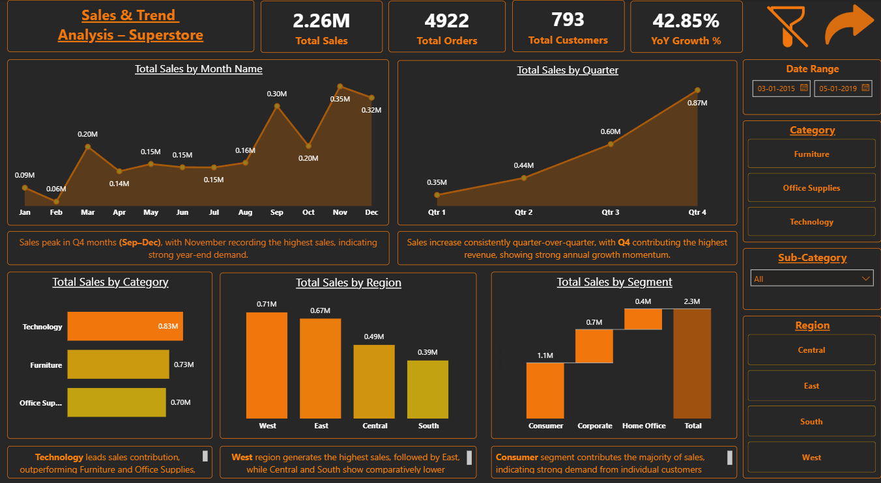
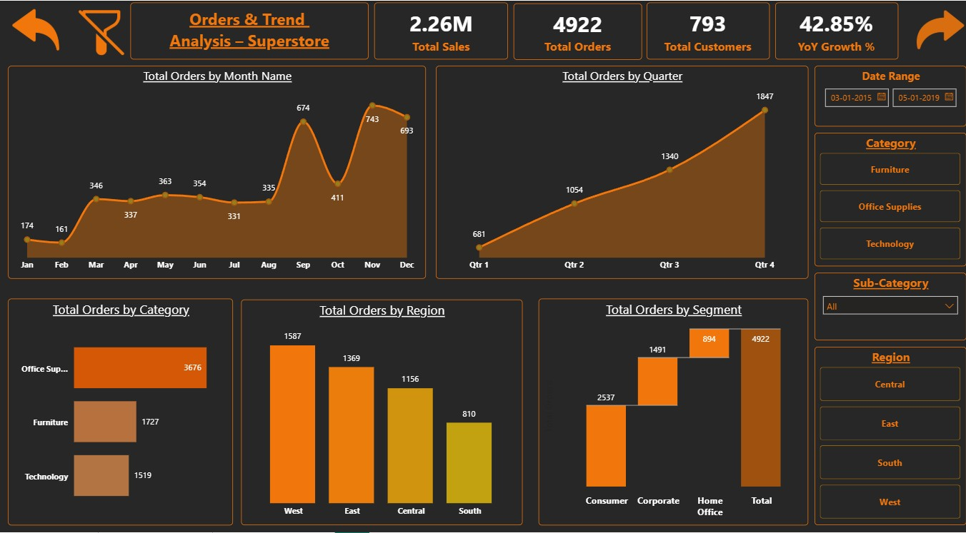
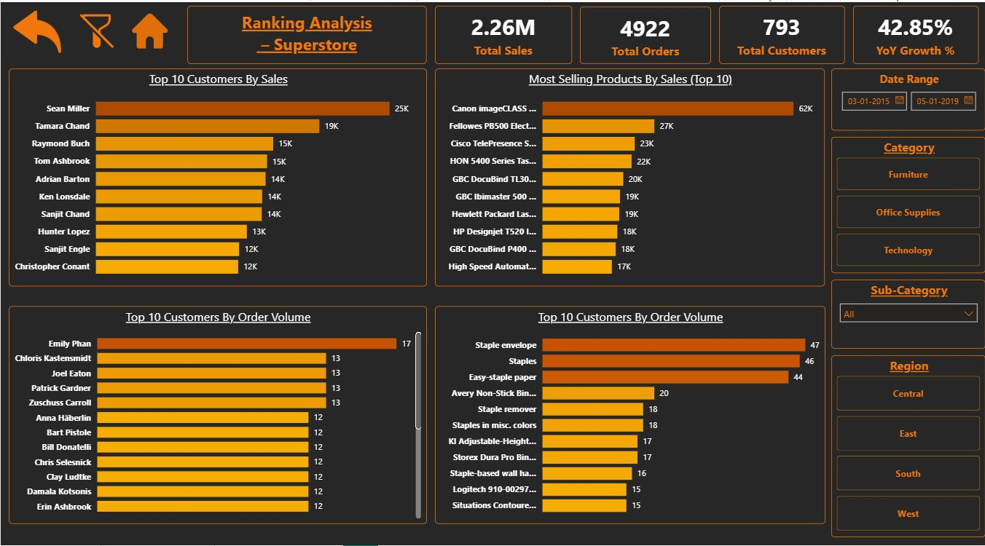

6.Key Insights
1.Shipping Mode
    - Insight
      - Standard Class alone contributes ~60% of sales & orders, while Same Day Contributes only ~5%
    - Implication
      - Customers are price-sensitive rather than speed-sensitive. Same Day may not justify its operational cost for the majority.
    - Action
      - Restrict Same Day to VIP/high-value orders only.
      - Bundle free/discounted First-Class shipping for high-margin categories to upsell without cost explosion.
2.Segment
    - Insight
      - Consumer segment drives ~51% of sales & orders, while Home Office contributes <19%.
    - Implication
      - Home Office customers may have lower awareness, lower frequency, or limited product fit.
    - Action
      - Launch Home-Office specific bundles (desk + chair + storage).
      - Run weekday-based B2B offers targeting small business
3.Region
    - Insight
      - West and East regions appear strong, but sales are highly concentrated in few state (California, Washington, New York, Pennsylvania)
    - Implication
      - Regional growth is fragile and over-dependent on limited geographies. Any dip in key states impacts whole region.
    - Action
      - Replicate CA/NY product mix & pricing strategy in adjacent underperforming states.
      - Plot city-level campaigns instead of broad regional campaigns.

4.Category
    - Insight
      - Technology drives value, while Office Supplies drives volume.
    - Implication
      - Revenue depends on fewer high-value Tech orders, increasing risk.
      - Office Supplies can be leveraged to improve customer retention & frequency.
    - Action
      - Cross-sell Tech items during high-frequency Office Supplies purchases.
      - Maintain deep inventory for Office Supplies to avoid stock-outs.
5.Trend
    - Year wise
      - Insights
        - Sales and orders show steady YoY growth, with 2018 contributing ~32% of total sales.
        - YoY sales growth (~5%) broadly aligns with average inflation level
      - Implication
        - Growth appears nominal rather than demand-driven, suggesting limited real business expansion and muted marketing impact
      - Action
        - Launch measurable demand-generation campaigns, especially in Q1 & Q2, with pre- and post-performance tracking.
        - Shift focus from price-led growth to volume levers such as customer acquisition, purchase frequency, and product mix optimization
6.Customer Segments
    - Insight
      - Majority customers are Regular/New, with <3% in Premium/VIP segments.
    - Implication
      - Business is volume-driven but lacks high-lifetime-value customers
    - Action
      - Introduce tier-based loyalty program with shipping & pricing benefits.
      - Identify top 10% customers and push personalized offers

